Route 53
So, Route 53 is a managed DNS or Domain Name System.
And what does the DNS do?
Well, It's a collection of rules and records, which help clients find the right servers through URLs.
Common records
Mapping www.google.com to an IPv4 address.
www.google.com => 12.34.56.78 == A record(IPv4 address)
If you are mapping www.google.com to a long IPv6 address, it's called the quadruple A record.
www.google.com => 2001:0db8:85a3:0000:0000:8a2e:0370:7334 == AAAA IPv6
If you map a host name to another host name,It's called a CNAME because we're
search.google.com => www.google.com == CNAME
If we are using a mail server to exchange emails then we use MX records
mail.EXAMPLE.com is the mail server to which it connects

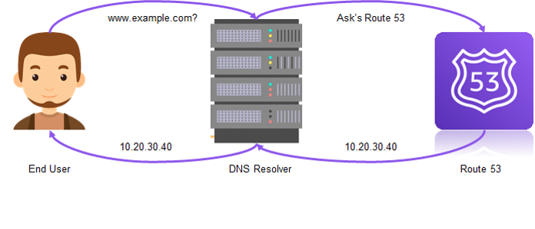

Routing Policies
Simple Routing policy:
Use for a single resource that performs a given function for your domain, for example, a web server that serves content for the example.com website.
Weighted Routing policy:
Use to route traffic to multiple resources in proportions that you specify.
Latency Routing policy:
Use when you have resources in multiple AWS Regions and you want to route traffic to the region that provides the best latency.
Failover routing policy:
Use when you want to configure active-passive failover
Geolocation routing policy:
Use when you want to route traffic based on the location of your users.

What is Route 53? (Super simple)
Route 53 is the internet’s phone book for your website.
When someone types google.com, Route 53 helps the internet find the correct server IP address and sends the user there.
It’s a DNS (Domain Name System) service provided by Amazon Web Services.

🧠 Easy way to remember: 3 Jobs of Route 53
Think of Route 53 = DNS + Traffic Cop + Health Checker

1️⃣ DNS – “Name ➜ Number”
📞 Phonebook job
- Humans remember names (example.com)
- Computers need numbers (IP address like 54.23.10.5)
- Route 53 translates name → IP
👉 “If you know the name, Route 53 finds the number.”

2️⃣ Traffic Routing – “Who should go where?”
🚦 Traffic cop job
Route 53 decides where to send users based on rules:
- Nearest server (lowest latency)
- Split traffic (50% to new app, 50% to old app)
- Different regions (US users → US server)
Common routing policies (remember S F L G W M):
- Simple
- Failover
- Latency-based
- Geolocation
- Weighted
- Multi-value
👉 “Route 53 controls traffic smartly.”

3️⃣ Health Check – “Is the server alive?”
❤️ Doctor job
- Route 53 checks if your server is healthy
- If a server is down, users are automatically sent elsewhere
👉 “If one server is sick, Route 53 avoids it.”

🔢 Why the name Route 53?
- Port 53 is the standard port used by DNS
- Route = routing traffic
- 👉 Route + 53 = DNS routing

🧩 One-line exam-ready definition
Route 53 is a highly available DNS service that converts domain names into IP addresses, routes users intelligently, and performs health checks.

🎯 Ultra-short memory trick
Route 53 =
- 📖 Phonebook (DNS)
- 🚦 Traffic cop (Routing)
- ❤️ Doctor (Health check)

